Project Development Phase
Functional & Performance Testing
Date | 01 October 2026
Team ID | SWTID-2026-4971
Project Name | Script-Controlled ACL – Restrict Record Access Based on Field Value
Maximum Marks | 10 Marks
Team Leader | Jaisri B S
Team Members | Irfana Thasnim M, Janani Sri L, Jeevika C, Jeevika R
Test Scenarios & Results
The screenshots below were captured in the ServiceNow instance during setup and testing.
Test ID | Scenario | Test Steps | Expected Result | Actual Result | Pass/Fail
FT-01 | Read ACL – EEE User | 1. Impersonate EEE User (bb1)  2. Open u_institution_details.list  3. Check visible records | Only records with Branch = EEE are visible | Only EEE records visible | Pass
FT-02 | Read ACL – User without role | 1. Impersonate user without bb1  2. Open table list  3. Check records | No records visible / Access denied | No records visible | Pass
FT-03 | Read ACL – Admin Override | 1. Login / Impersonate Admin  2. Open table list  3. Check all records | All records (ECE, EEE, CSE) are visible | All records visible | Pass
FT-04 | Create ACL – with bb2 | 1. Impersonate user with bb1+bb2  2. Click New on table  3. Try to create record | New button available and record can be created | New button available, create works | Pass
FT-05 | Write ACL – with bb3 | 1. Impersonate user with bb1+bb3  2. Open EEE record  3. Edit and Save | Record can be edited and saved | Edit and save successful | Pass
FT-06 | Delete ACL – with bb4 | 1. Impersonate user with bb1+bb4  2. Open EEE record  3. Delete the record | Record can be deleted | Delete successful | Pass
FT-07 | Combined Roles Full Access | 1. Assign bb1+bb2+bb3+bb4  2. Perform Create, Read, Write, Delete | All CRUD operations work on EEE records | All CRUD operations successful | Pass
PT-01 | ACL Evaluation Time | 1. Open list with 20+ records  2. Observe load time | List loads within acceptable time (< 3 sec) | List loads quickly | Pass
PT-02 | Script Performance | 1. Check Advanced Script has no heavy GlideRecord  2. Verify simple gs.hasRole checks | Script remains lightweight and fast | Script is simple and efficient | Pass
Screenshots
A. Users, Roles and Table Setup
Figure 1: Roles BB1, BB2, BB3 and BB4 created in ServiceNow
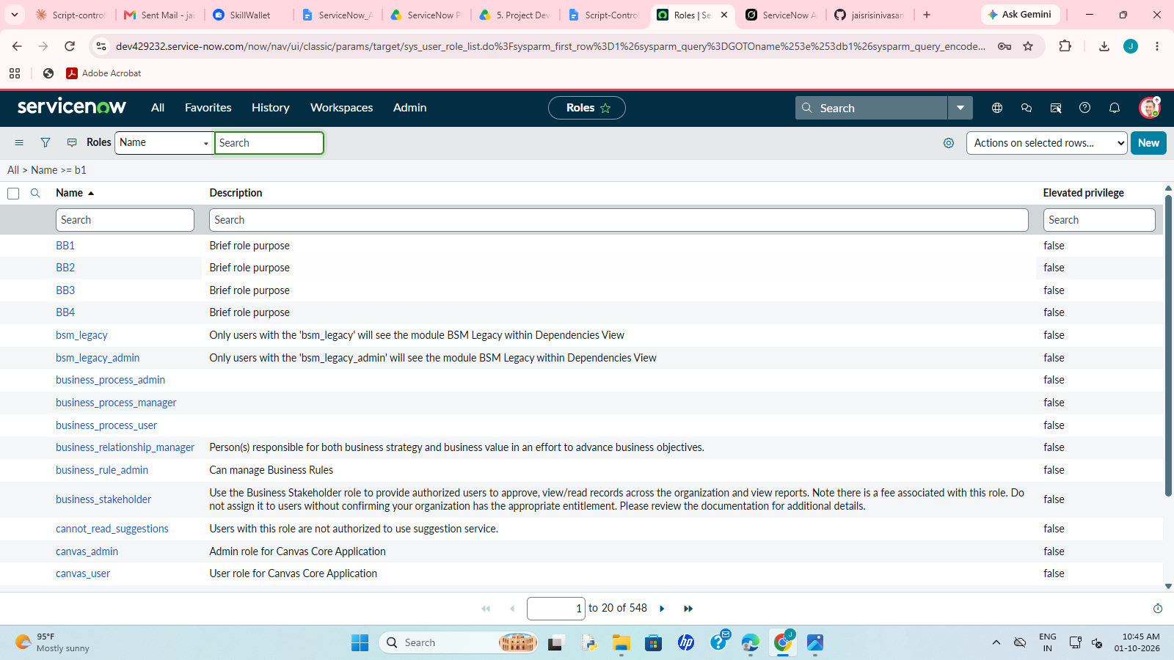
Figure 2: Test user "EEE User" with assigned roles (Roles tab)
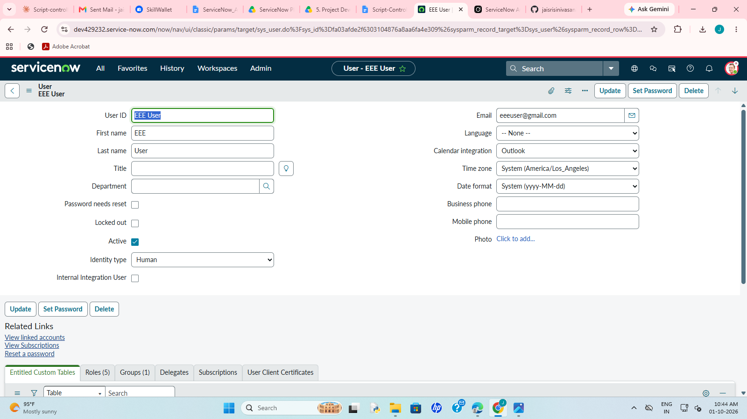
Figure 3: Institution Details table with Branch (ECE, EEE, CSE), Student Name, Roll Number, Faculty Name, Email and Phone Number
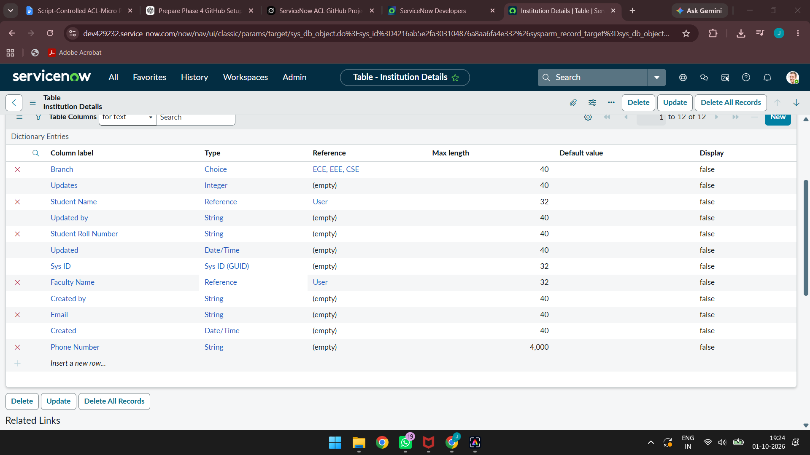
B. Access Control Lists
Figure 4: ACLs configured on the u_institution_details table (read, create, write and delete)
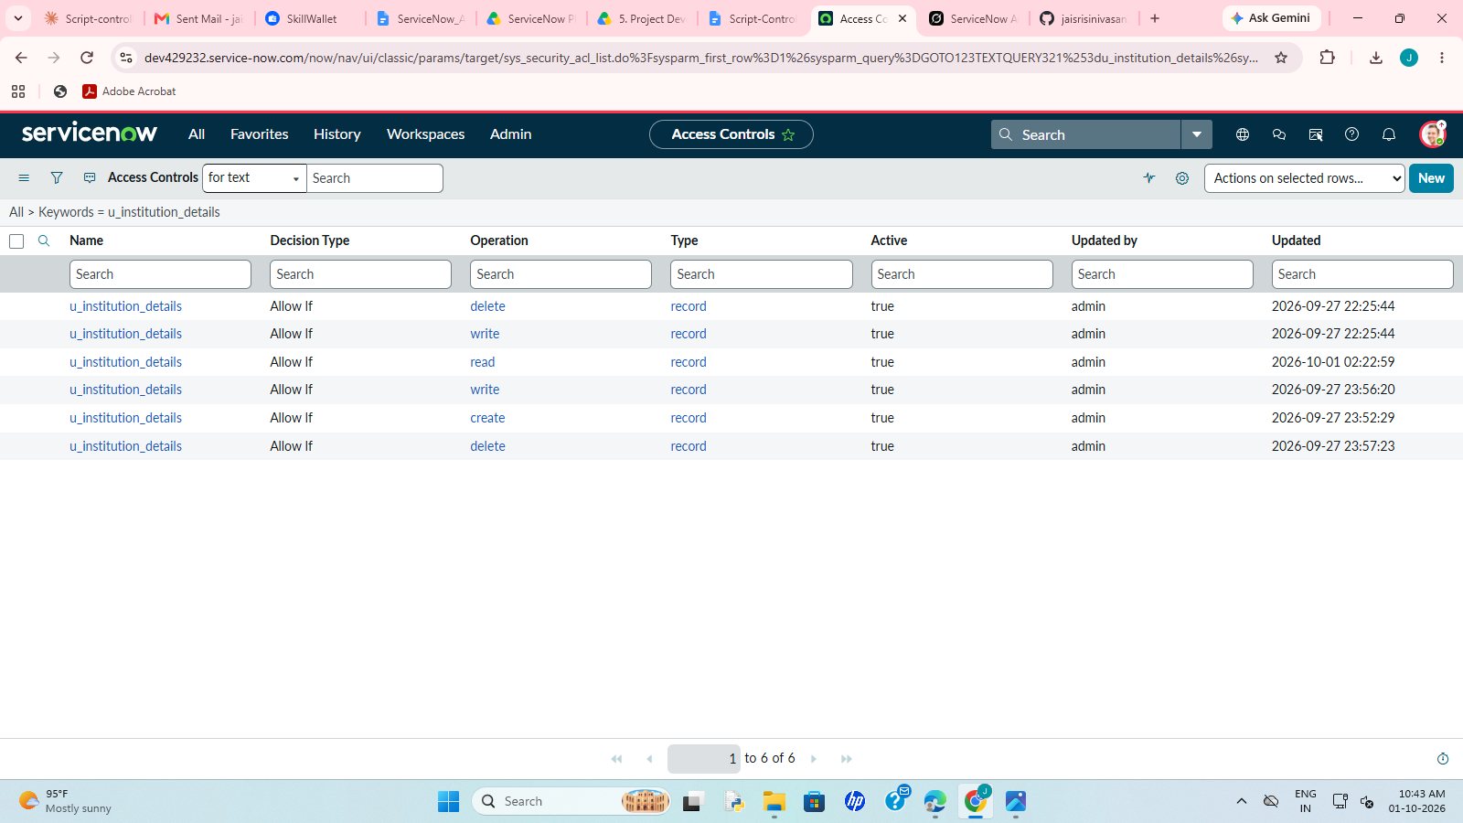
C. Test Evidence
Figure 5 (FT-01): EEE User sees only records with Branch = EEE
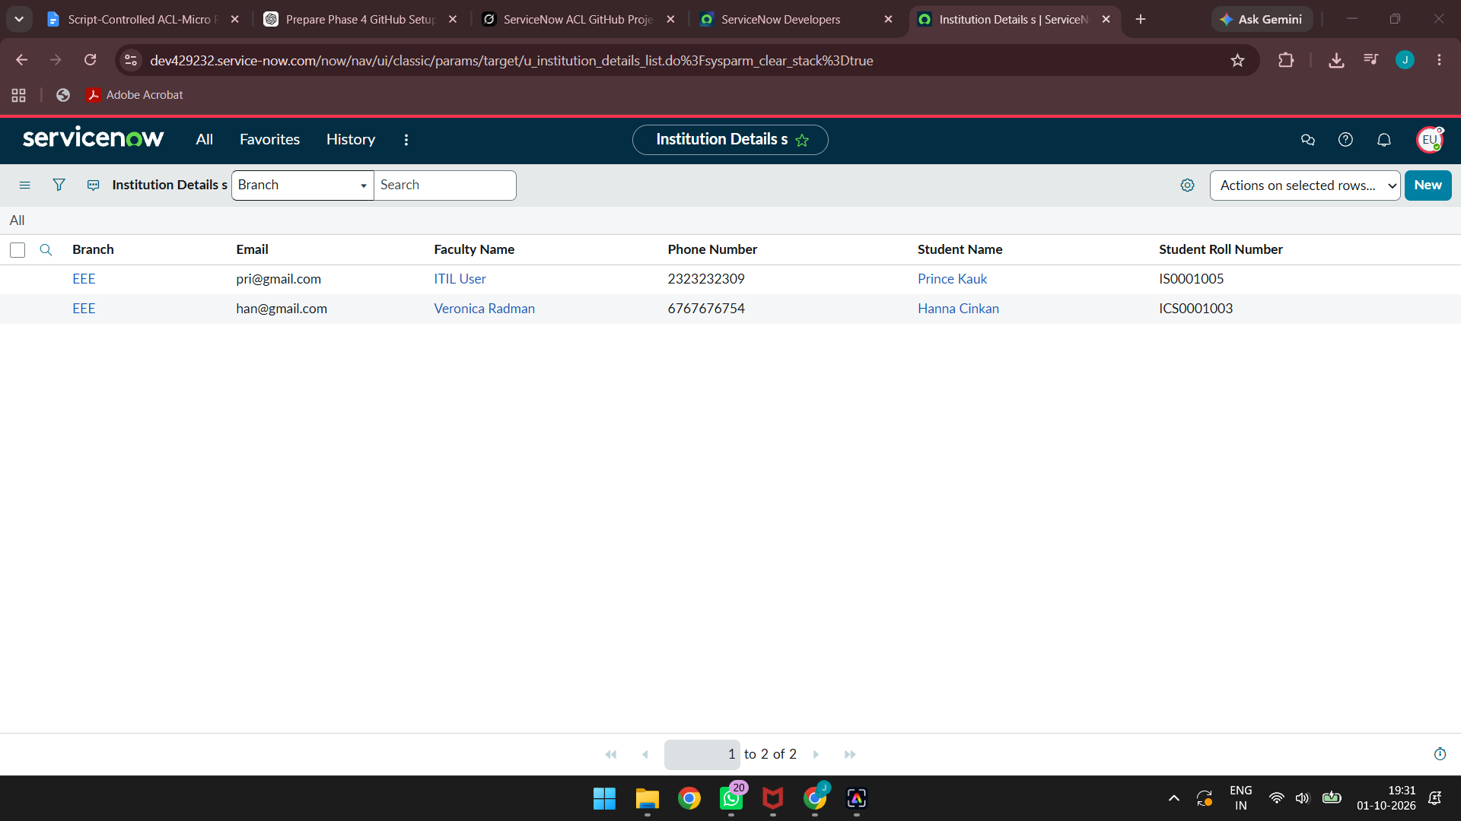
Figure 6 (FT-03): Admin sees all records (ECE, EEE and CSE)
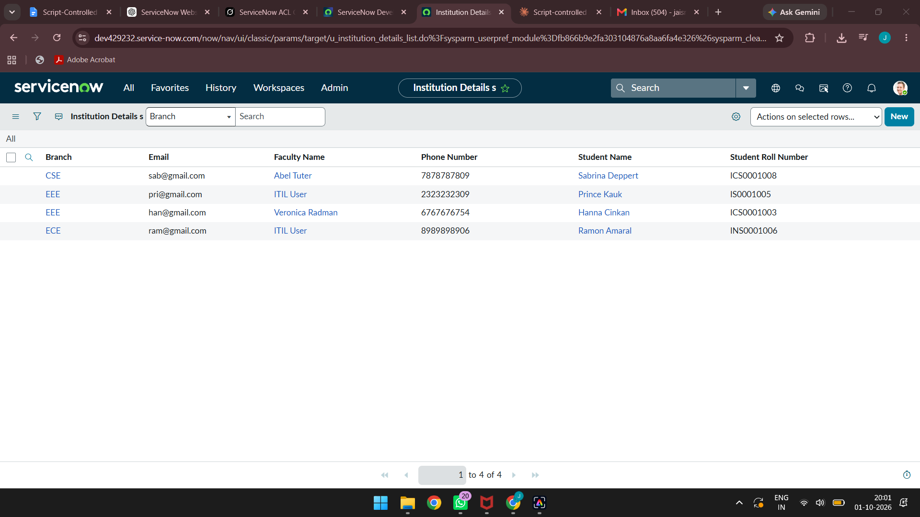
Figure 7 (FT-04): Create ACL – New button available for the user with bb2
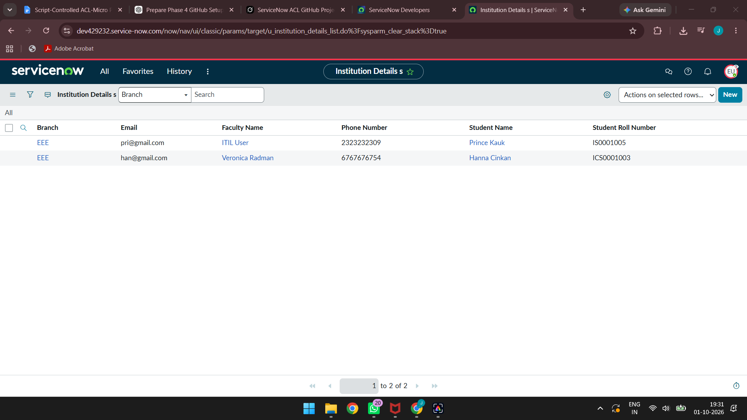
Figure 8 (FT-05): Write ACL – editing a record (Email field) with bb3
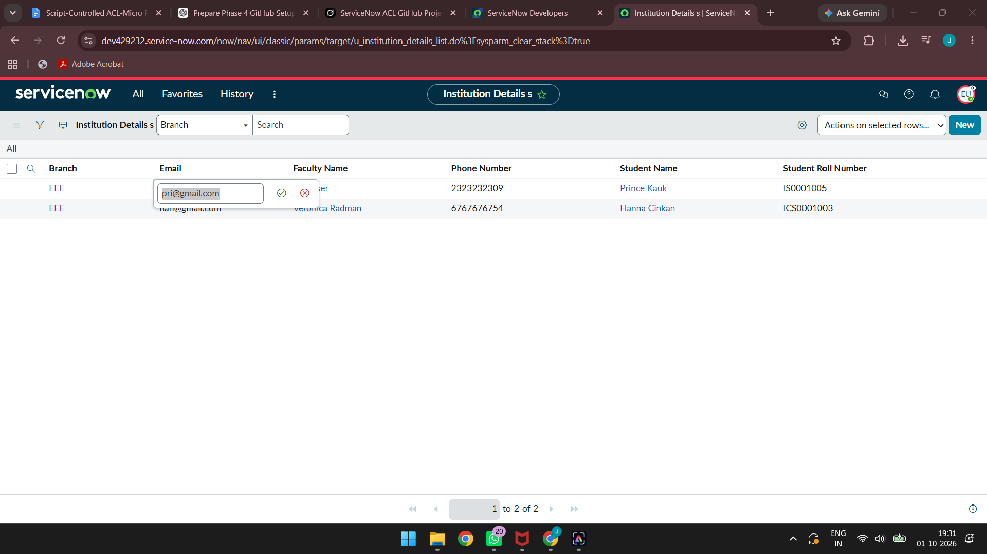
Figure 9 (FT-06): Delete ACL – delete confirmation for a selected record with bb4
